|  |  |  |  |  |
| --- | --- | --- | --- | --- |
| Subsector / Módulo: Ingles  DOCENTE: GABRIEL AHUMADA | | | | |
| Guía de Actividades  INGLES  **SECOND LEVEL** |  |  |  |  |
| Nombre: | Curso: 2°Medio | | Fecha: | |
| ***Objetivos***:  **13-15-16**  ***Contenidos:***  -Vocabulario de acerca de problemas globales | | | | |

**Global issues are those that affect the whole planet and potentially all the people who live on it. Here’s a list of several global issues.**

**Highlight those that affect our country.**

Problemas globales son aquellos que afectan a todo el planeta y potencialmente a la gente que habita en ella. A tu izquierda hay una lista de diversos problemas.

*Traduce y destaca aquellos que afecten nuestro país.*

Global issues

* Global warming
* Poverty
* Hydric crisis
* Deforestation
* Overpopulation
* Corruption
* Religious conflicts
* Inequality
* War conflicts
* Drug addictions

**Examples**

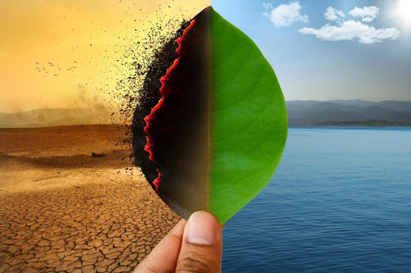

I-Read the following text and answer the questions:

GLOBAL WARMING

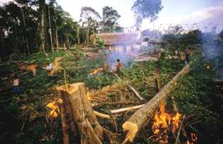

Experts in climatology and other scientists are extremely concerned about the changes to our climate. Admittedly, climate changes have occurred on our planet before. For example: there had been several ice ages or glacial periods.

These changes were different from the modern ones because they occurred gradually and naturally. The current changes aren’t the result of natural causes, but of human activity. Furthermore, the changes are occurring alarmingly rapid.

The major problem is perhaps, that the planet is warming up. According to some experts, this warming, known as global warming, has been occurring in the last 10,000 years. The implications for the planet are very serious. Rising global temperatures could give rise to such ecological disasters such as floods and droughts. This could have a harmful effect on agriculture.

This unusual warming of the earth has been caused partly by so- called greenhouse gases, such as carbon dioxide, being emitted into the atmosphere by car engines and modern industrial processes, for example. Such gases, not only add to the pollution of the atmosphere, but also create a greenhouse effect, by which the heat of sun is trapped. This leads to the warming up of the planet.

Politicians are also concerned about climate change and there are now regular meetings on the subject, attended by representatives from many of the world’s industrialized countries. In Kyoto, Japan in 1997, it was agreed that the most industrialized countries would try to reduce the volume of greenhouse gas emissions and were given targets for their reductions.

It was also suggested that more forests should be planted to create so- called “sinks” to absorb greenhouse gases. At least part of the problem of rapid climate change has been caused by too drastic deforestation.

Sadly, the targets are not being met. Even more sadly, global warnings about climate changes are often still being regarded as scaremongering.

1. What climate changes have taken place before the present time?  
   ____________________________________________________________________________________________________________________________________

2. What are the main differences between modern climate changes and the ones that occurred in the past?  
_________________________________________________________________________________________________________________________________________

3. What were the agreements reached in the summit in Tokyo?  
_________________________________________________________________________________________________________________________________________

4. Which suggestions were made and why?  
_________________________________________________________________________________________________________________________________________

5. Express your opinion: Is global warming true or false? Give reasons.  
______________________________________________________________________________________________________________________________________________________________________________________________________________